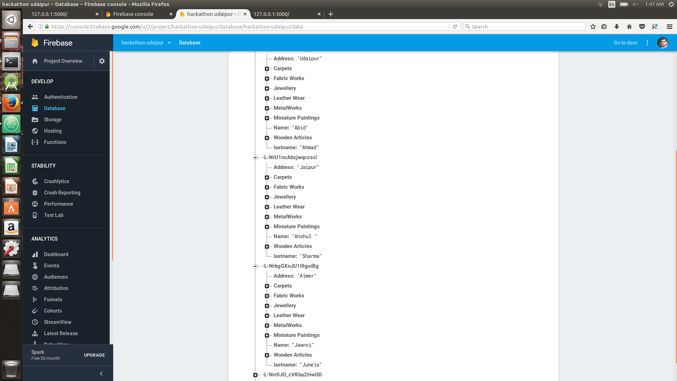
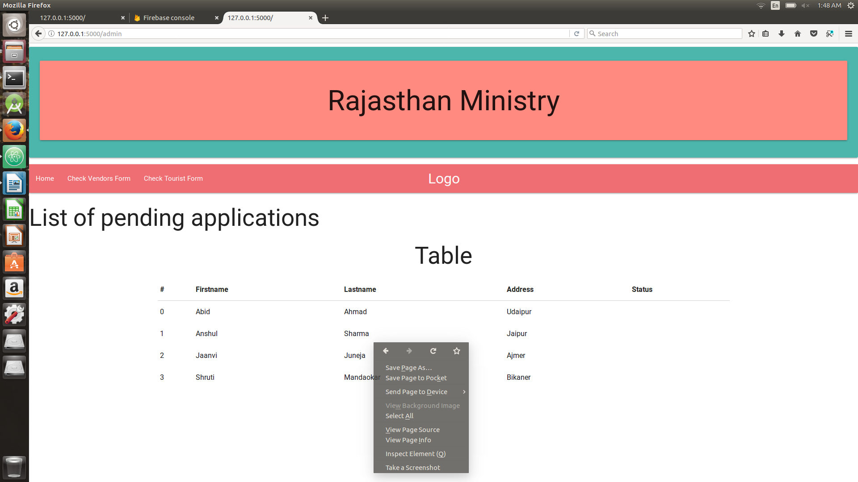
Status Accepting webpage

FirebaseDataBase(Online):-

Frameworks and programming languages used:-

1)Python :-
1)flask
2)pyerbase
2)HTML
3)CSS:-
1)MaterialCSS by google
4)Firebase for online database

How to run:-
python3 accept.py
in terminal or command prompt

The Webportal is not currently completer and has broken links.

